**Painswick PROBUS Club – AGENDA 2024**

**The 31st Annual General Meeting of the Club will be held at 11.30 on Wednesday 13th November 2024 at Painswick Centre**

1. Apologies
2. Approval of Draft Minutes of the 30th AGM held on Thursday 14th September 2023 (Annex A below).
3. Matters arising from Previous AGM 2023
4. President’s Report
5. Treasurer’s Report (Accounts Annex B below)
6. Appointment of the Independent Financial Reviewer
7. Appointment of Officers:-
8. President Michael Houghton
9. Vice President Nick Slader
10. Secretary – John Rohrbeck
11. Treasurer – John Rohrbeck
12. Speakers Secretary -Nick Slader
13. Additional Committee Member - Rob Soutar
14. Any Other Matters

The Committee requests members having any other matters that require discussion to notify President Michael before the AGM.

If time permits, the draft constitution at Annex c can be discussed.

The meeting will be followed by a talk by Steve Tilley on “Walking the Coast”.

Wine will be available at the end of the meeting

List of Annexes.

A. Draft Minutes of Previous AGM 2023

B. Summary of Accounts 2024

C. CONSTITUTION OF PAINSWICK PROBUS CLUB Draft 4

**Annex A**

**Draft Minutes of Previous AGM 2023**

The thirty-first Annual General Meeting was held on Thursday 14th November 2023 in the Richmond Village Auditorium.

Members in attendance: Basil Butler, Ian Eastwood , Henry Hall, Ken Hemming, Russell Herbert, Michael Houghton, Michael Irving, Peter Jenkins, Philip Morris, Douglas Robinson, John Rohrbeck, Paul Sparks, Michael Steed, Nicholas Slader.

1.0 INTRODUCTION

The Club President Mike Steed welcomed the members and guests and wished to thank Richmond Village for the use of their Auditorium. Since July Richmond Village has been used to hold the Club meetings while during this period the Painswick Centre underwent a management reorganisation and the Beacon Hall was redecorated. The plan is to return to the Beacon Hall at the Centre in the New Year.

2.0 APOLOGIES

Apologies were received from the following members: Ian Breckels and Alan Shearer.

3.0 MINUTES of the AGM HELD ON 7th SEPTEMBER 2022

There were no comments on the matters arising and the minutes were unanimously approved.

The minutes were ‘signed off’ by the President.

4.0 PRESIDENT’S REPORT

The president’s report was circulated prior to the AGM.

In his report the President thanked all members and the committee for their support since he was first elected in April 2020, taking over the presidency from Somerset Moore. During this period we experienced the disruption from the Covid 19 epidemic and more recently the relocation to Richmond Village Auditorium. The President thanked Philip Morris for co-ordinating with Richmond Village management for the use of the auditorium. The Club planned to return to the Painswick Centre Beacon Hall in the New Year.

Current membership stands at 43 and the club looks to boost membership in the forthcoming year. Members were urged to encourage further membership through personal contacts etc.

The President drew the attention of members to the proposed revisions to the Club’s constitution. The revisions to the constitution would be subject to be discussion later on in the meeting.

Several members were thanked for giving talks on their respective careers in the last year. Members’ talks included those given by Michael Houghton, Ian Breckels, Paul Sparks and Henry Hall. Thanks are due to Henry Hall in his role of Speakers Secretary, for arranging a wide range of talks given by outside speakers.

Sadly, he had to report the death of former members since last year’s AGM, these were: Keith Hardwidge, Maurice Maggs, and Geoffrey Archer.

5.0 TREASURER’S REPORT

The Treasurer, John Rohrbeck presented a brief summary of the financial status and a forecast for the next year. The financial statement has been verified by an independent reviewer, Ian Breckels. The financial report was approved at the meeting.

The Treasurer forecast is that the Club will have a cash balance going into 2024 of £807. Current deposit held in the bank is £1510.

The proposal is to increase the membership annual fee to £75 but to delay the payment until 1st January 2024. The increase reflects a general increase in the speakers fees, including travel and also hire of the hall.

This motion was approved unanimously by a show of hands.

6.0 APPOINTMENT OF INDEPENDENT FINANCIAL REVIEWER

Ian Breckels has accepted the role of the independent financial reviewer of the Club accounts.

This appointment was approved at the meeting.

7.0 APPOINTMENT OF OFFICERS.

President Michael Houghton, proposed by Mike Steed and seconded by Russell Herbert.

Vice President Nicholas Slader, proposed by Michael Houghton and seconded by Mike Steed.

Both appointments were approved unanimously by a show of hands.

The following committee members were proposed and accepted:

Treasurer John Rohrbeck, Secretary Ian Eastwood, other committee members are Mike Steed and Philip Morris.

The role of Speakers Secretary remains vacant as Henry Hall plans to leave Painswick early next year. Henry Hall has carried out this function for a number of years and the meeting expressed their thanks for all the work he has done since taking over from John Courts.

8.0 REVISIONS TO THE CONSTITUTION.

Proposed revisions of the Club’s Constitution were circulated prior to the meeting. The objective of the amendments was to broaden the appeal of the Club and encourage and enhance the opportunities for social gatherings. Amongst the matters discussed were extending the membership to ladies, a more inclusive definition of the term ‘retired professionals’ people in line with more current trends. No conclusion was reached in the time available and it was decided that the Committee would give the wording in constitution further consideration and report back to the membership with revised suggestions for further discussions. Feedback on the draft changes to the Constitution by members would be very welcome.

(Post meeting note: it was agreed at a subsequent routine Club meeting that the Club should be marketed as ‘Painswick Valley Probus Club’. It was felt that this name would be more broadening and welcoming to potential new members residing nearby, and that ladies should be encouraged to join.)

9.0 VENUE FOR FUTURE MEETINGS

Starting in the New Year, meetings will commence on every other Thursday morning commencing at 11.00h in the Beacon Hall at the Painswick Centre, subject to its availability. The bar will open from 12.00h and hopefully this will make time for a pleasant social gathering after the talk and any other formalities.

10.0 ANY OTHER MATTERS

Basil Butler wished special thanks on behalf of the Club to Mike Steed for undertaking a long period as the President, over two years, and coping with the ramifications of Covid 19 on the Club activities.

No new matters were raised at the meeting.

11 NEXT MEETING

Paul Sparks gave Part 2 of his talk on his Life and Experiences in hospitality.

The next meeting is on Thursday 30th November at Richmond Village Auditorium. The speaker will be Gil McHattie and the title of the talk is ‘The Knights Templar’.

Ian Eastwood

November 2023

**Annex B**

**Summary of Accounts 2024** – please see next page

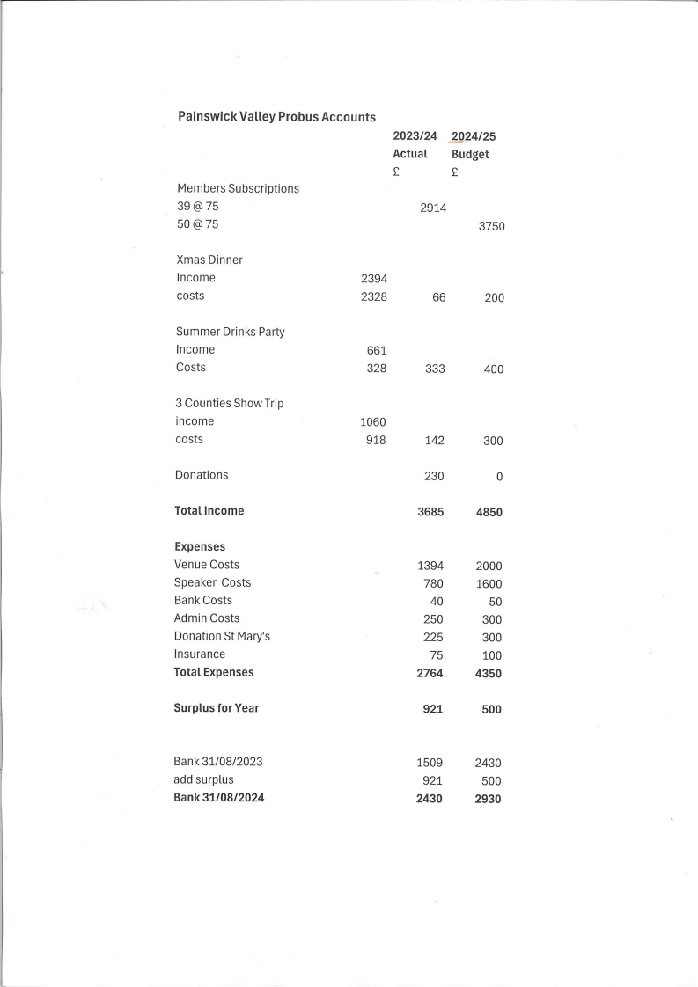**Annex C**

**CONSTITUTION OF PAINSWICK PROBUS CLUB Draft 4**

PURPOSE: the purpose of the Club is to provide a regular meeting point for

ladies and gentlemen who have probably retired from their main first career

and now have varied business interests or have fully retired. Membership will

be particularly appreciated by those welcoming the opportunity of meeting

others in similar circumstances and participating in activities of general

interest.

THE RULES

!. TITLE: The club shall be called “The Painswick Probus Club” or such title as

the Club may decide.

2. MEMBERSHIP Membership shall be open to all ladies and gentlemen aged

50 and over, residing in, or in the vicinity of Painswick, who have fully or

partially retired. The restrictions regarding residence and age may be waived at the discretion of the Committee.

The membership maximum shall be sixty or such other number as shall be decided at an Annual General or Special General Meeting.

3. SUBSCRIPTIONS Subscriptions shall be determined at each Annual General

Meeting after receiving the Treasurer’s report.

4. CONSTITUTION The Club shall be independent of any other organisation

and its affairs shall be conducted under the authority of its own membership.

There shall be a President, Vice-President, Immediate Past President, Honorary

Secretary, Honorary Treasurer, and Speaker Secretary, as circumstances

permit, and the roles of events organisation, communication, and website

management can be allocated to the positions outlined, or given to an

additional members of the Committee.

The affairs of the Club shall be managed by the members of the Committee all

to be elected at the Annual General Meeting.

In normal circumstances the President shall retire from office on completion of

one year in the Chair. He shall automatically become an ex-officio Committee

member for the year following his retirement.

Three members of the Committee shall constitute a quorum and the

Committee shall have the power to co-opt between AGMs and to appoint one or more sub-committees.

5. MEETINGS

An Annual General Meeting shall be held each year at a time, date and place

decided by the Committee. At least three weeks notice of such a meeting

should shall be given to members.

The Hon. Secretary shall call a Special General Meeting on the written request

of not less than five members and shall give to members three week’s notice of

such meetings.

Voting at all meetings shall be by show of hands or by ballot if so determined.

In the event of an equal division of votes the chairman of the meeting shall

have a casting vote.

6. ACCOUNTS An Income and Expenditure Account for the Club’s financial year

shall be presented for approval at the Annual General Meeting, after audit

review by a person appointed at the previous AGM.

The Committee shall appoint the Club’s bankers and shall authorise the

Treasurer and their deputy to make payments by BACS.